# Question 03

## Code

clc

clear

close all

time=linspace(0,12,13);

Depth=[0 2 5 8 15 28 32 49 57 68 110 109 130];

velocity_forword=[];

for i=1:length(time)-1

velocity_forword(i)=Depth(i+1)-Depth(i);

end

velocity_backword=[];

for i=2:length(time)

velocity_backword(i-1)=Depth(i)-Depth(i-1);

end

velocity_centered=[];

for i=2:length(time)-1

velocity_centered(i-1)=(Depth(i+1)-Depth(i-1))/2;

end

acc_centered=[];

for i=2:length(time)-1

acc_centered(i-1)=Depth(i+1)-2*Depth(i)+Depth(i-1);

end

acc_backword=[];

for i=3:length(time)

acc_backword(i-2)=Depth(i)-2*Depth(i-1)+Depth(i-2);

end

acc_forwrod=[];

for i=1:length(time)-2

acc_forwrod(i)=Depth(i+1)-2*Depth(i+1)+Depth(i);

end

velocity_forword

velocity_backword

velocity_centered

acc_forwrod

acc_backword

acc_centered

## Output

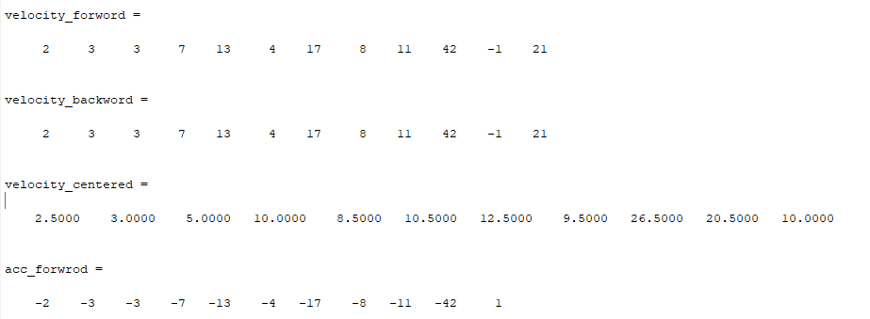

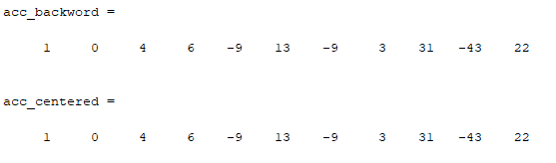

# Question 04

## Code

clc

clear all;

close all

XYZ=136

f=@(x)(-3.8*(x -XYZ)^2 -8.6*(x -XYZ) -500-XYZ);

a=f(0);

f=@(x)(-3.8*(x -XYZ)^2 -8.6*(x -XYZ) -800-XYZ);

b=f(0);

c =8;

iteration=50;

itera_rect = (zeros(1,iteration));

itera_trapz = (zeros(1,iteration));

itera_simp = (zeros(1,iteration));

for i = 1:iteration

temp = (b-a)/i;

rect_sum = 0;

for p = 1:i

X = a + p*(temp)-(temp/2);

Y = sqrt(((X^2)-(c^2)))/X;

rect_sum = rect_sum + Y*temp;

end

itera_rect(i) = rect_sum;

temp = (b-a)/(i-1);

trapz_sum = 0;

for q = 1:i

X = a + ((q-1)*temp);

Y = sqrt(((X^2)-(c^2)))/X;

if (q == 0)||(q == i)

coeff = 0.5;

else

coeff = 1;

end

trapz_sum = trapz_sum + (coeff*Y*temp);

end

itera_trapz(i) = trapz_sum;

simp_sum = 0;

for r = 1:i

X = a + ((r-1)*temp);

Y = sqrt(((X^2)-(c^2)))/X;

if (mod(r,2) == 0)

coeff = 4;

else

coeff = 2;

end

if (r == 0)||(r == i)

coeff = 1;

end

simp_sum = simp_sum + (coeff*Y*temp*(1/3));

end

itera_simp(i) = simp_sum;

end

plot(itera_rect)

hold on;

plot(itera_trapz);

hold on;

title('Error in surface area with all method');

xlabel('===>Iteration');

ylabel ('====>Error Values');

plot(itera_simp);

hold on

legend('Rectangle Method','Trapeziod','Simpson Rule');

grid on;

## Output

